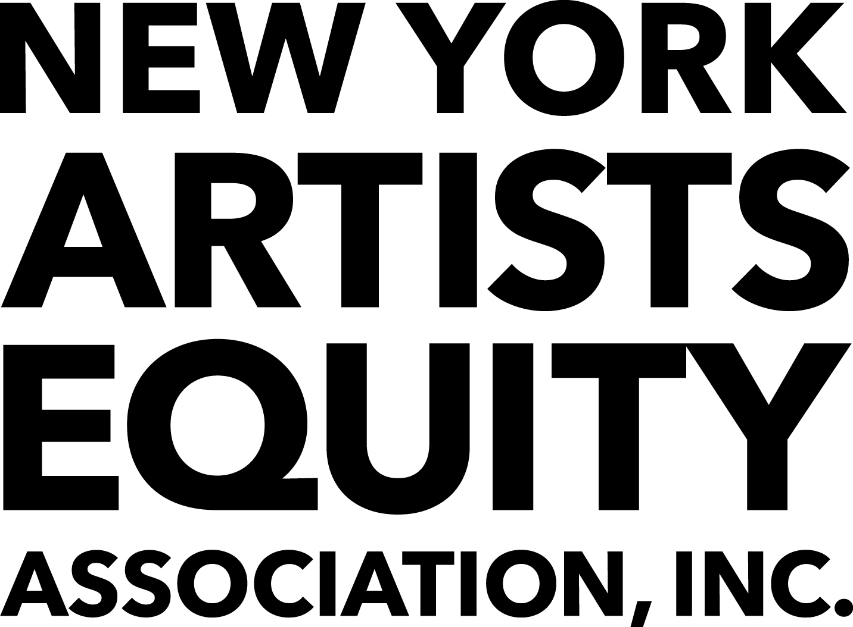

Thank you for your interest in NY Artists Equity. Based on our years of experience in the NYC art scene, here are our top tips to get you on your way to landing a gallery show.
- HAVE A STRONG PORTFOLIO
Your website should be a clear representation of your work but you should also have a strong set of images on your mobile device when someone asks. Use social media to include in progress and detail shots, inspiration from other artists and periods.
- WRITE AN ARTIST’S STATEMENT
Everyone should have an artist’s statement but also make sure it represents who you are. Don’t include art-speak that you don’t use naturally. Describe your practice, style and ideas. Make it accessible and a draw to your work.
- BE ARTICULATE
Know how to talk about your work to different kinds of people. Not everyone needs the art historical lineage, but some do. Recognize the difference between the ten second general description and the one minute pitch. Prepare to explain why you do the work you do.
- BE IN TOUCH WITH OTHER ARTISTS
Keep in contact with the artists you know and get to know others, too. Invite colleagues to do studio visits and critiques. Participate in social media interviews and conversations. Artists share opportunities, group exhibits, grants and residencies with friends, and let them know what to skip.
- KNOW THE CALENDAR
Appreciate what galleries and directors are juggling by keeping up with major local and international art events. Major fairs, grant applications, let alone cultural holidays, are reasons to give people extra time. Be respectful of their obligations when you do need to be in contact to show that you understand the expectations they are trying to fulfill.
- FIND GOOD MATCHES
Take a look at the mission statement and recent exhibitions of any gallery that you are considering. Know that their goals align with yours or you will waste your time and theirs. Be specific about why your work belongs there. Spend time at the gallery and attending any talks or events it hosts, online or off. Know the crowd it attracts because if you feel comfortable, then your work will do well there, too.
- ACCEPT THE UNEXPECTED
Use any feedback to better understand galleries’ processes. Rejections occur but they can help you refine your work and find better matches. Interestingly, pitching one thing might lead to another opportunity. Stay open to what may come!

To learn more about the benefits of membership go to http://www.nyartistsequity.org/membership-for-artists.

